**Assignment**

**SE 101 -ISE (Introduction To Software Engineering)**

**Submitted by**

**SAIF ALI**

**4305-FBAS/BSSE/F21**

**Shahid Ramzan**

**4346-FBAS/BSSE/F21-B**

**Ahmad Raza**

**4329-FBAS/BSSE/F21-B**

**Taimoor Ul Hassan**

**4303-FBAS/BSSE/F21-B**

**Faizan aziz**

**4330-FBAS/BSSE/F21-B**

**Submitted to**

**Sir Shakir Rasheed**



Department of Computer Science and Software Engineering

INTERNATIONAL ISLAMIC UNIVERSITY ISLAMABAD

Semester Fall 2022

**Class Diagram of School Management System:**

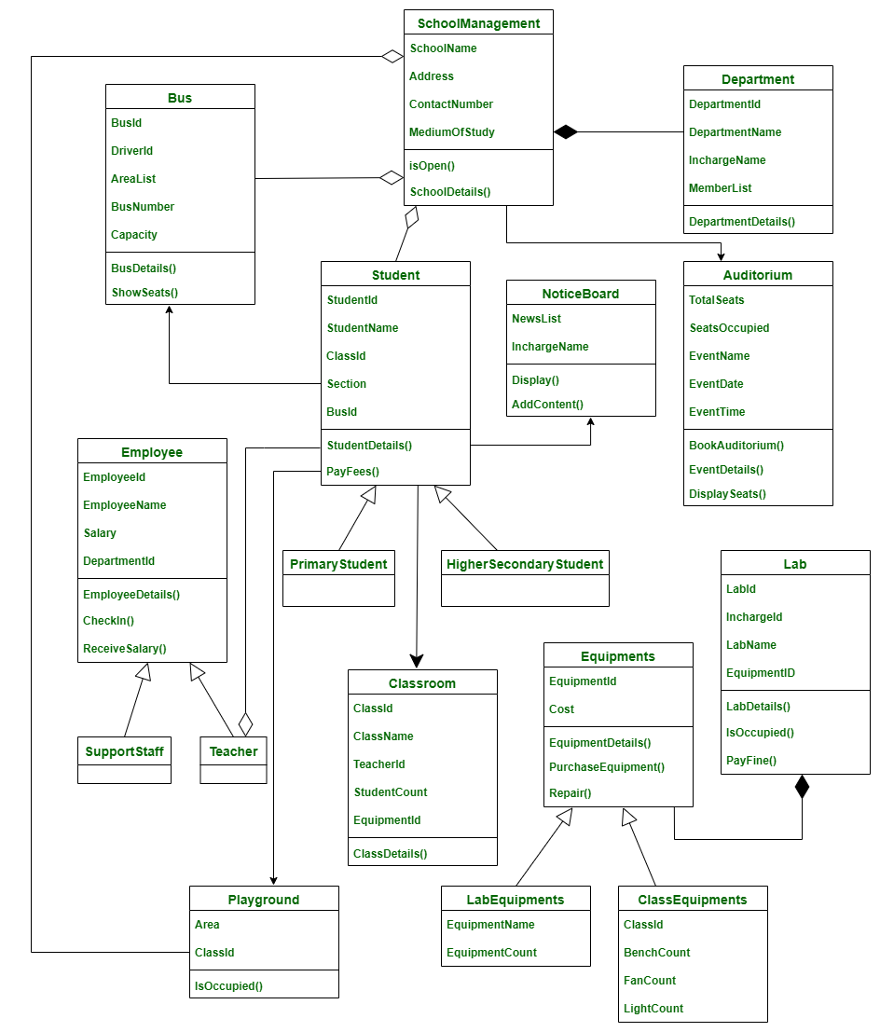

**Sequence Diagram of School Management System:**

